Quick start guide for new Union Institute and University students

All new Union Institute and University (UI&U) students receive a welcome email containing their UI&U ID number, their login credentials and an introduction to the systems and applications they will use the most. This document provides detailed descriptions of the resources mentioned in the welcome letter. Please contact the UI&U help desk (513-487-1137) if you need assistance.

Your username and (initial) password
  - Username: The letter U + your 6 digit UI&U ID + email.myunion.edu
    - Example: U123456@email.myunion.edu
  - Initial password: UIU (all caps) + the last six digits of your Social Security number + !
    - Example: UIU123456!
    - When you first log in you will be prompted to change your password to something more personal. Please include at least one upper case and one lower case letter and at least one number.
  - You can reset your password and verify your account information on the Password and ID Help page in CampusWeb, under the Help Desk tab: https://campusweb.myunion.edu/ICS/HELP/Password_and_ID_Help.jnz
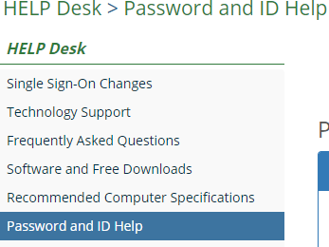

Single Sign-On (SSO)

UI&U has a single sign-on (SSO) application that lets a student access multiple resources with one set of login credentials. After logging in you can access your UI&U email account, the student portal and learning management system (Brightspace) and the Library research databases without the need to login a second time. If you go to CampusWeb, Brightspace or the Library website to login you will be redirected to the sign-in page on Microsoft 365 (see image below) and then returned to your CampusWeb home page or the appropriate Library page or Brightspace. If your email account is your destination the sign-in page will deliver you to your Outlook inbox page.
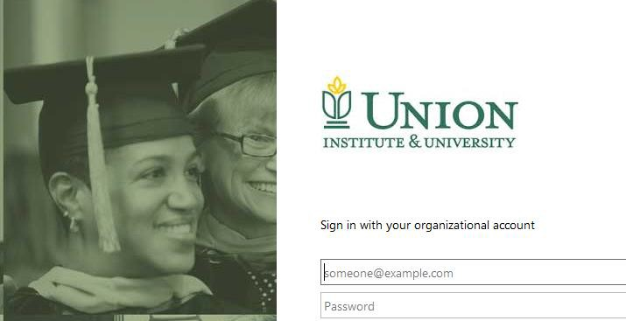

Your UI&U email account

We license Microsoft's Office 365 platform to provide email and productivity tools to all of our students. Access your email account at https://outlook.office.com and login with your username and your personal password. Though your username begins with U + your ID number (e.g., U123456@email.myunion.edu) your email address will appear as firstname.lastname@email.myunion.edu to those you communicate with. Note: all official University communications will be sent to this email account. Please login frequently.

CampusWeb

CampusWeb (https://campusweb.myunion.edu/ics) is the UI&U student portal. You will use CampusWeb to view your grades, register for classes, manage your financial account, visit the Writing Center, etc.

Brightspace

Brightspace (https://succeed.myunion.edu) is Union’s Learning Management System. You will take all of your online course from this site.

