BS Course Checklist for Students
If you are taking an online course via Brightspace, use the following checklist to ensure you are ready to pass your class with flying colors.
- Log in to succeed.myunion.edu
Use your Union email address and password
- Landing page:
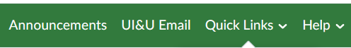
□ Announcements – Check for any new University wide announcements.
□ UI&U Email - There is a Quick Link to your UI&U Email. This is the official form of communication. Check your email frequently.
□ Quick Links - This tab gives you access to CampusWeb, UIU Library, the Academic Catalog and Zoom. (Students can register for a free zoom account with their Union email address.) This tab is available from your courses as well.
□ Help - This tab has links to the UI&U Help Desk and various Brightspace support. This tab is available from your courses as well.
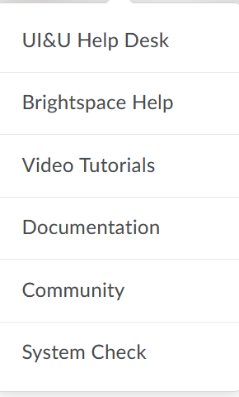
Brightspace User Support information is available on the right side of the landing page: D2L Help Line: 1-877-325-7778
- Click on the desired term/course from the My Courses Widget:
□ The course home page will display announcements, a Table of Contents and faculty profile.
□ Read any course announcements. You can dismiss announcements after you have read them if desired.
- From the Content tab
□ Read any content in the Overview.
□ Click on the Start Here to read the About this Course, the Syllabus, Faculty Information (Instructor Communication / Response Policy) and UI&U’s Resources (Writing Center, ADA Accommodations, Academic Integrity and Incomplete Policy).

- Directions for Course Navigation include:
□ Once an item has been viewed it will display a checkmark.
□ Note: access to assignments and quizzes may be embedded in the content item however, all assignments and quizzes can be viewed and submitted from the Assignments tab then selection either Assignments or Quizzes.
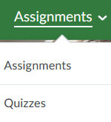
□ Note: access to discussions may be embedded in the content item however, all discussion are can be viewed and completed from the discussions tab.
- Content Items (not all courses will have each item listed below):
□ Organization of material maybe in weeks or units. Read and follow the directions for each content item.
□ Examples of items may be Overview and objectives, Readings, Lectures, Videos, PowerPoints and Web Pages etc.
- Assignments
□ When completing assignments or quizzes, be sure to read all the information available on the page for due dates and times. Some items may have additional attachments, instructions or video notes.
- Grades Tab
□ This displays a grade for the assignments that have been submitted and graded in addition to any faculty feedback. It may not reflect your final standing in the course.
- Classlist tab
□ Email and a course directory can be accessed via the Classlist tab.
- Course Tools
□ This is another area to connect to various tools in the course including Class Progress.

